1.- Create a user with user group
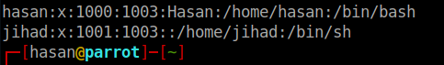

- Create two directories in user's home directory named os-concepts and ubuntu-is-the-best
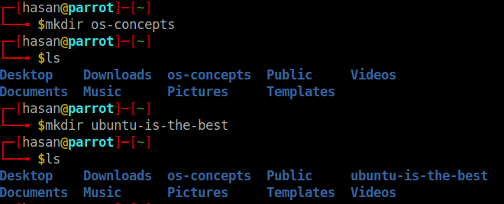
- Create two files on each directory
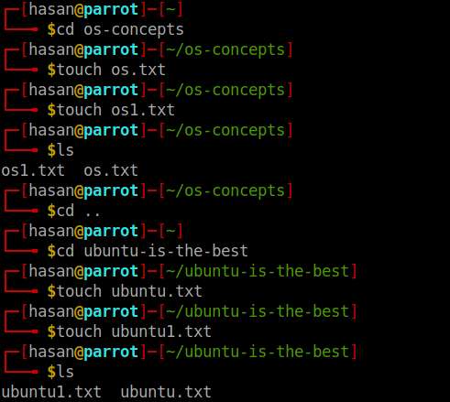

- List the files with detailed information ( including file permission )

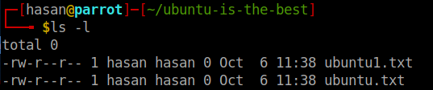
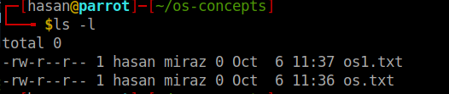
-

- update file permission so that owner can read,write and group can only read and others can not do anything

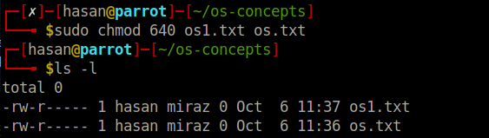

-

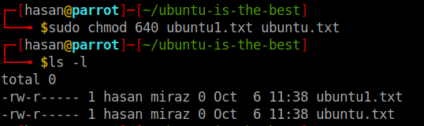

Create another group
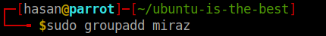

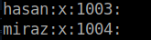

- Update file ownership to the newly created group

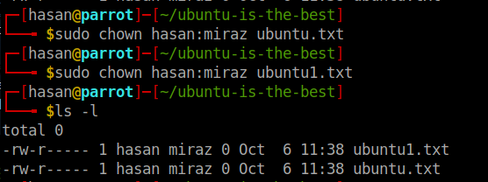

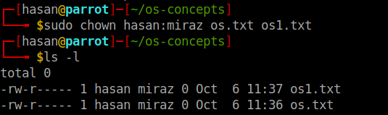

- Add the user to the new group

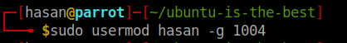

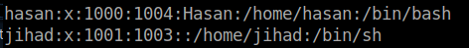

- Create a file called crash.in ( File should contain the word crash in it ) in different directories and then find the file in all the locations using find command
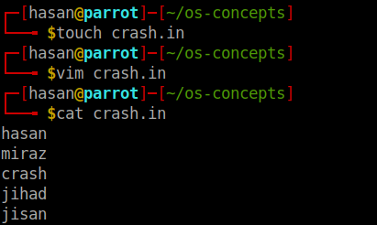

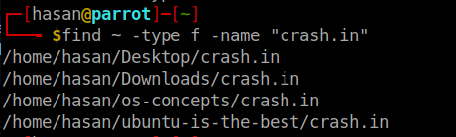

- Then, replace the lines with crash to broken to all files ( use sed, xargs )

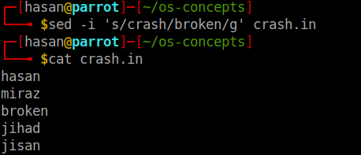

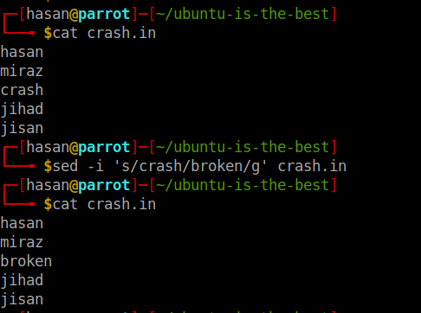

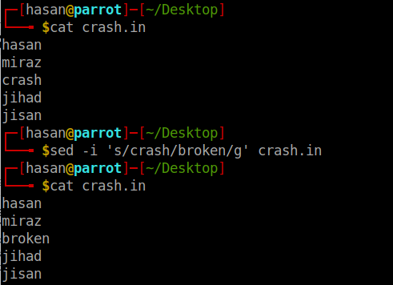
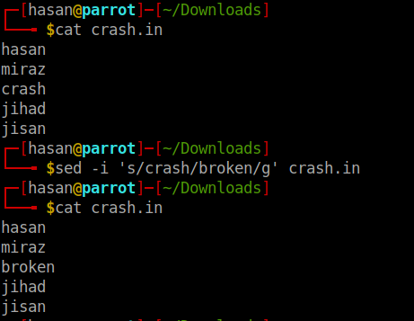
\

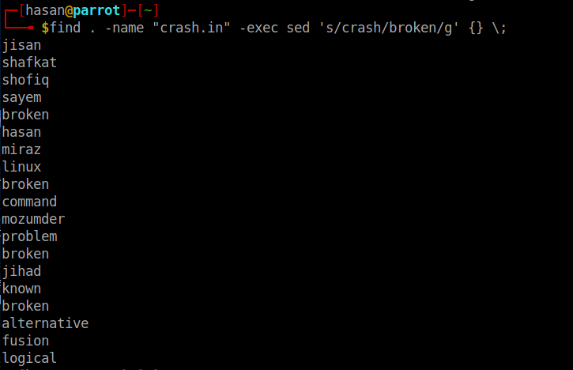
All changes in one command

